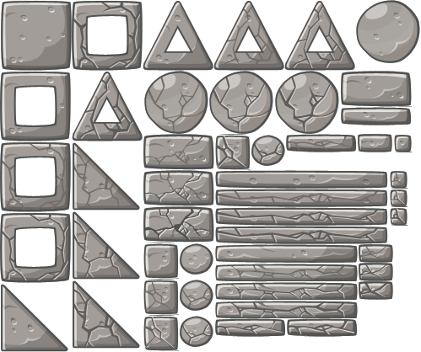
1
2
3
4
6
7
13
8
14
5
9
10
11
12
23
22
21
19
20
18
16
28
17
15
32
33
26
25
27
29
30
31
34
35

24

36

37

38
40

39
41

42

SE COMIENZA DE ARRIBA,DERECHA,ABAJO,IZQUIERDA:

- (0,334.4) (0,418)(83.17,418)(83.17,334.4)
- (83.17,334.4) (83.17,418)(166.34,418)(166.34,334)
- (166.34,334) (166.34,418)(249.51,418)(249.51,334.4)
- (249.51,334.4) (249.51,418)(332.68,418)(332.68,334.4)
- (332.68,334.4) (332.68,418)(415.85,418)(415.85,334.4)
- (415.85,334.4) (415.85,418)(499,418)(499,334.4)
- (0,250.8)(0,334.4)(83.17,334.4)(83.17,250.8)
- (83.17,250.8) (83.17,334.4)(166.34,334.4)(166.34,250.8)
- (166.34,250.8) (166.34,334.4)(249.51,334.4)(249.51,250.8)
- (249.51,250.8) (249.51,334.4)(332.68,334.4)(332.68,250,8)
- (332.68,250,8) (332.68,334.4)(415.85,334.4)(415.85,250.8)
- (415.85,250.8) (415.85,334.4)(499,334.4)(499,250.8)
- (0,167.2)(0,250.8)(83.17,250.8)(83.17,167.2)
- (83.17,167.2) (83.17,250.8)(166.34,250.8)(166.34,167.2)
- (0,83.6)(0,167.2) (83.17,167.2)(83.17,83.6)
- (83.17,83.6) (83.17,167.2)(166.34,167.2)(166.34,83.6)
- (0,0)(0,83.6)(83.17,83.6)(83.17,0)
- (83.17,0) (83.17,83.6)(166.34,83.6)(166.34,0)

374
249.34
124.67
0.0


129.3
388
258.6


0.0
78.3
156.6
234.9
313.2
391.5
470
135


374
129.3
249.34
388
124.67
258.6
0.0


0,0
79
158
237
316
395
111


511
340.6
170.3
0,0
166.67
333.334
500

